****Youth Night

at

St. Francis Convent

Hankinson, ND

2024-25

**Each session will include:**

* **getting acquainted & catching up with friends**
* **discussing Living Joy:9 Rules that will Change Your Life**
* **praying together**
* **enjoying each other’s company, snacks & games**

**We will meet 7-9pm the 3rd Friday of each month during the school year. Teens of all denominations are welcome!**

**The next opportunity to join this group will be Friday, August 16, 2024; please RSVP by Wednesday, August 14 so we are prepared to accommodate everyone.**

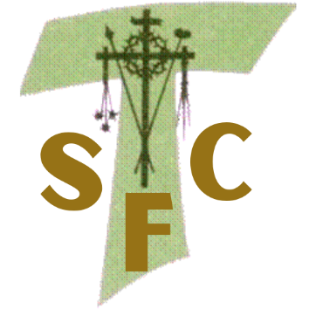**2024-25 dates for Youth Night at the Convent are:**

August 16 September 20 October 18 November 15

December 20 January 17 February 21 March 21

April 11* May 16

*\*April 11 is the 2nd Friday rather than the 3rd Friday of the month\**

**IF you would like to participate, you can save your spot by emailing Sr. Mary Ruth ([srmaryruh@sfcretreats.org](mailto:srmaryruth@sfcretreats.org)) or calling the Franciscan Retreat Center (701-242-7195). Please RSVP by Wednesday before the date you plan to attend.**